Article title
  - article title in the English language
AUTHOR'S NAME AND SURNAME, AUTHOR'S NAME AND SURNAME
ABSTRACT: Replace this text with an English annotation of 5-10 lines. The abstract introduces the content of the article. In it, the author also states the article goals and the applied procedures. The recommended length is of 100 - 250 words.
(blank line Arial 8)
KEYWORDS: Replace this text with English keywords – 3 to 5 terms. Each expression should start with a capital letter and end with a full stop.
(blank line Arial 8)
INTRODUCTION (Arial 11)
You can find the electronic form of this template at https://www.fbi.uniza.sk/stranka/sablona-clanku. Write your text in Arial 10, without indenting the first line in the paragraph. Separate the paragraphs with one blank line (Arial 10). Align to block.
- CHAPTER (Arial 11)
Use single-level or multi-level automatic chapter numbering. In the text, use single left-aligned bullets or multilevel bullets of the same type, differentiated by bullet size:
- xxxx,
- xxxx,
- xxxx.
(blank line Arial 10)
Use this format to cite the literature used (Author, year).
Table 1 Table title (Author & Author, year)
Column name | Parameter 1 | Parameter 2
Text, text, text... | Text – number | 06.02.2020
Text, text, text... | Text – number | 06.02.2020
(blank line Arial 10)
Write the number and table title (Table 1) according to the above model. Do not put a full stop after the table number. Put a fixed space (ctrl-shift-space) before the table number. Refer to the table in the text as a reference to Table 1. Adjust the width of the table to the width of the window. Complete the font type and size in the table. Values in tables must not be linked to other programmes (e.g. Excel).
(blank line Arial 10)
Text, text, text, text, text, text, text, text, text, text, text, text, text, text, text, text, text, text, text, text, text, text, text, text, text, text, text, text, text, text, text, text, text, text, text, text, text, text, text, text, text...
(blank line Arial 10)
Write formulae using the formula editor.
(blank line Arial 10)
(1)
where: S – content,
π – constant,
r – radius.
(blank line Arial 10)
Text, text, text, text, text, text, text, text, text, text, text, text, text, text, text, text, text, text, text, text, text, text, text....
(blank line Arial 10)
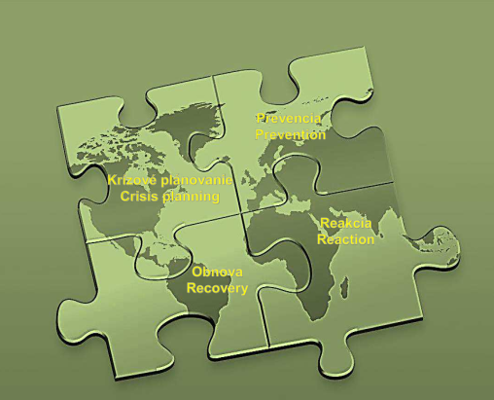
Figure 1 Figure title (Author, Author & Author, year)
Write the number and title of the figure according to the above model. Put a fixed space (ctrl-shift-space) before and after the figure number. The title - the text below the figure – should always start with a capital letter as at the beginning of the sentence. We do not put a full stop at the end of the text. Refer to the figure in the text as a reference to Figure 1. The size of the figure must not exceed the margins. The figure should be centred. Complement qualityDopln kvalitu; Figures and graphs must not be linked to other programmes (e.g. Excel).
CONCLUSION (Arial 11)
The author is responsible for the factual and linguistic accuracy of the paper. Recommended paper structure - IMRaD model (IMRD).
ACKNOWLEDGEMENTS (Arial 11)
Project, financing, author's team, etc.
REFERENCES (Arial 11)
Blakey, N., Guinea, S., & Saghafi, F. (2017). Transforming undergraduate nursing curriculum by aligning models of clinical reasoning through simulation. In R. Walker, & S. Bedford (Eds.), HERDSA 2017 Conference: Research and Development in Higher Education: Curriculum Transformation (pp. 25-37). Hammondville, NSW: Higher Education Research and Development Society of Australasia. Retrieved from http://www.herdsa.org.au/research-and-development-higher-education-vol-40-25 (conference article)
Carey, B. (2019, March 22). Can we get better at forgetting? The New York Times. https://www.nytimes.com/2019/03/22/health/memory-forgetting-psychology.html (newspaper article)
Fagan, J. (2019, March 25). Nursing clinical brain. OER Commons. Retrieved September 17, 2019, from https://www.oercommons.org/authoring/53029-nursing-clinical-brain/view (webpage)
Grady, J. S., Her, M., Moreno, G., Perez, C., & Yelinek, J. (2019). Emotions in storybooks: A comparison of storybooks that represent ethnic and racial groups in the United States. Psychology of Popular Media Culture, 8(3), 207–217. https://doi.org/10.1037/ppm0000185 (journal)
Sapolsky, R. M. (2017). Behave: The biology of humans at our best and worst. Penguin Books. (book)
Zákon č. 131/2002 Z. z. o vysokých školách a o zmene a doplnení niektorých zákonov. (Act)
Order the references alphabetically. For more information, follow the APA citation format - https://apastyle.apa.org/style-grammar-guidelines/references/examples (Arial 8,5)
(blank line 10)
Author's name and surname - 1, academic titles
Contact information (workplace, address)
e-mail:
Author's name and surname - 2, academic titles
Contact information (workplace, address)
e-mail:

